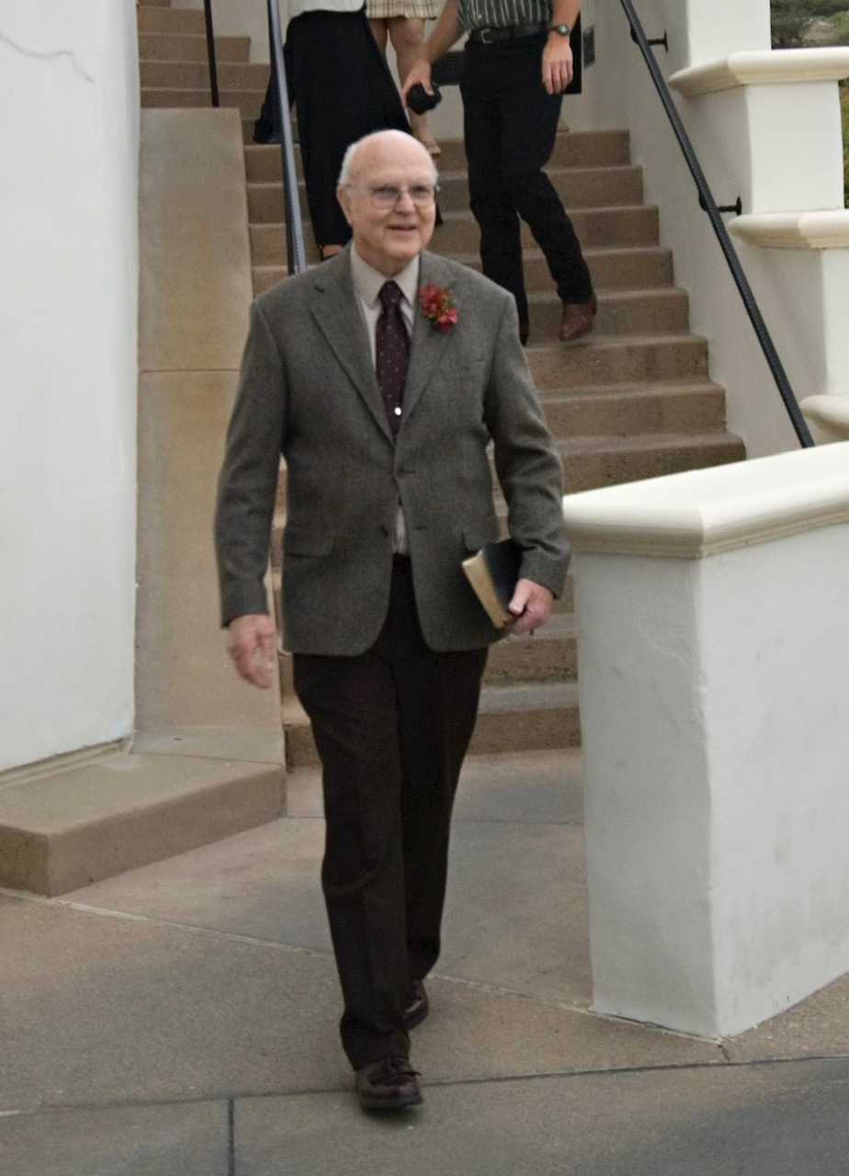

**Please join us for a celebration of the life of Vernon Carson**

Vernon went home to Heaven August 31, 2022 and we will be celebrating his life on

September 24, 2020, 10:00 a.m. at the

Allen Mortuary Chapel

247 N. Broadway, Turlock CA

A catered lunch will immediately follow the service at the

Carnegie Arts Center

250 N. Broadway, Turlock CA

Following lunch, family members are invited to Rick Carson’s home

to enjoy one of Vernon’s favorite things, Root Beer Floats.

6148 Eleanor Avenue

Oakdale, CA